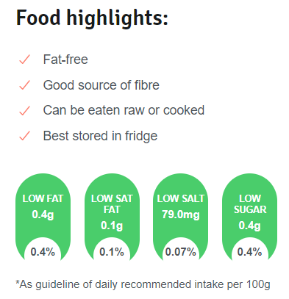

**Spinach**

Spinach, with its delicate flavour, can be eaten raw in salads, made into soups or sautéed with garlic and oil to make a simple vegetable dish. It is packed with vitamins and minerals and provides dietary fibre.

## Why spinach is good to eat

* Spinach is an excellent source of vitamins A, B2 and B6, C and K (important for helping your blood to clot).
* It also contains minerals such as iron, potassium (which helps to regulate blood pressure) and manganese (involved in the regulation of brain and nerve function).
* Spinach contains dietary fibre, which is important for a healthy bowel.
* Energy – 100 g of spinach supplies 50 kJ.

## How to store and keep spinach

Store spinach in a vegetable storage bag in the crisper section of your fridge. Spinach will keep for a few days when stored this way.